5 Semi-supervised anomaly detection method
There are various events in some complex video scenes, and each event may happen randomly, which makes it difficult to describe every scene accurately through specific patterns. In order to improve the ability of the model to represent video scenes, we further propose a semi-supervised model learning method. We divide the clips into different categories according to their behavior information, and learn an individual topic dictionary for each type of videos, so as to ensure that each class of samples can be described accurately by the model.
5.1 Coding of labeled clips
Given training sample set 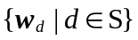, record the labeled samples as 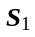 and the unlabeled samples as 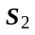. The semi-supervised method is aimed to find the map from sample to codes through labeled samples, which can also achieve good coding for unlabeled samples. For the labeled samples in the video, we make full use of their category information for supervised learning. We train the model separately for each class of samples and obtain an unique topic dictionary called category dictionary.
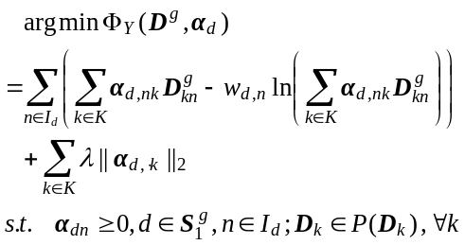 (1)
where 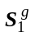denotes the g-th class sample set in the labeled training samples and 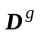denotes the category dictionary corresponding to the g-th class samples. Each row of the category dictionary represents a partial motion pattern that constitutes a kind of behavior. Through the above method, each kind of labeled samples can be modeled using its own dictionary, and we can reconstruct the video clip with higher accuracy.
5.2 Coding of unlabeled clips
Due to the difficulty and high cost of labeling samples, it is impossible to manually label all massive data. Model training process cannot only rely on the labeled samples. The proper use of unlabeled samples also seems crucial. We have used each class of labeled samples to train the category dictionary. Each dictionary can well interpret the videos in its corresponding class but cannot achieve good coding for all test samples. Therefore, it is hard to choose the correct dictionary for unlabeled clips coding. To solve this problem, we combine all category dictionaries to form a large topic dictionary D containing complete motion patterns, and use this dictionary to encode unlabeled samples.
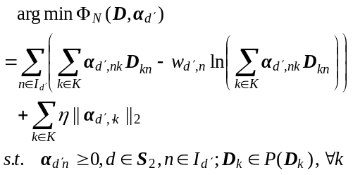 (2)
where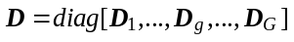is the dictionary made up of all G category dictionaries in video clips. It is able to interpret all kind of samples with high precision since there is complete semantic motion information in the topic dictionary.
5.3 Semi-supervised model learning
We have mentioned how to encode the labeled and unlabeled samples respectively. Referring to the sparse topic model introduced before, the semi- supervised model should have the following structure:
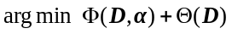 (3)
Where 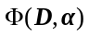includes the reconstruction error and sparse constraint terms of labeled and unlabeled samples. 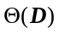denotes the constraint term of dictionary which usually adopts ℓ1 norm or ℓ2 norm. The ℓ1 norm constraint of the dictionary is adopted in the sparse topic model. It mainly emphasizes the sparsity of the dictionary in the learning process, which reflects the characteristic that only a few bases play a major role in the composition of the sample. The ℓ2 norm is used in semi-supervised learning process. Although its sparsity is not as strict as ℓ1 norm, but it is supposed to enhance the structure information and improve the discrimination ability of the model. The semi-supervised model is represented as:
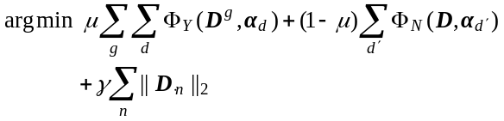(4)
where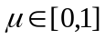is a coefficient to balance the effects of labeled and unlabeled samples on model learning. The advantage of the above methods is that the labeled samples are used to learn category dictionaries for different classes of video scenes, and for a large number of unlabeled samples, although they cannot be directly used to learn a specific dictionary, their coding coefficients are still mainly related to the corresponding category dictionaries due to the sparsity constraint. Hence, the discrimination power of the model is greatly enhanced.
5.3 Optimization
The optimization strategy is similar with the sparse topic model which can be divided into two parts: sparse coding process and dictionary learning process. Each process also has two cases according to whether the sample is labeled or not.
5.3.1 Sparse coding
In the sparse coding process, category dictionary is used to encode labeled samples as equation (1) shows. 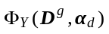is convex over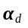. So the coordinate decent method can be used for this optimization by solving the problem for each element alternatively. The proof process is described below. First deriving the function:
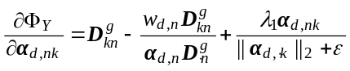(5)
where is a small enough positive number which is used to avoid the denominator equaling zero. Then taking the second derivative:
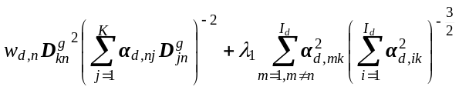(6)
The above formulation is positive, hence 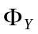is strictly convex for each 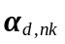and its minimum value will be obtained at the extreme point. Let 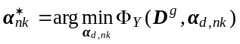. Since the value of word codes should be no negative, the final solution is 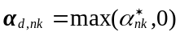. The coding is completed after all the elements of 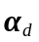are obtained. The optimization for the equation (2) is similar with the above process.
5.3.2 Dictionary learning
In order to display the relationship between category dictionaries and the joint dictionary. We define a matrix Q:
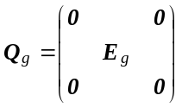 (7)
Where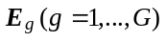is an identity matrix with dimension of N, which corresponds to the category dictionary :
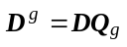 (8)
For the labeled training samples, they are used to learn the corresponding category dictionary. Assume that the word code vector is fixed. The learning process for the dictionary of class g can be expressed as:
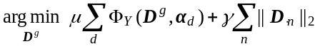 (9)
Here we adopt a similar solution to the sparse coding process described above. That is, solving the problem for each element of dictionary alternatively. Taking the derivative on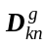:
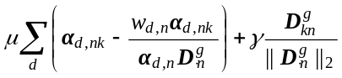 (10)
Since its second derivative is positive, the coordinate decent method is also adopted here to solve the problem (9).
For the unlabeled training sample set, we learn the joint dictionary through the following function:
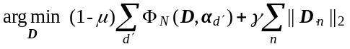 (11)
The optimization method is as same as equation (9). The sparse coding process and dictionary learning process are performed alternatively until the convergence of code vectors as shown in Algorithm 1.

5.4 Anomaly detection
Abnormal events have various definition in different methods. Most methods treat events that have not appeared or cannot be accurately described by models as anomalies. In this work, we have already summarized all the abnormal scenes in the video. We need to find which category the test sample belongs to, so as to determine whether it is normal or abnormal.
A number of category dictionaries are obtained in the process of dictionary learning, and the test samples can be reconstructed by each dictionary respectively. The reconstruction cost is calculated by:
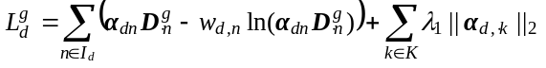
When the reconstruction cost gets smaller, it means that the contribution of this category dictionary gets greater, and the sample is more likely to belong to this class. Since the domain of 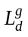is different for different samples, in order to demonstrate the reconstruction process better, we define the reconstruction accuracy and use it to find the corresponding label as shown below:
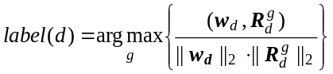
where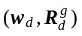denotes the inner product of the two vectors, and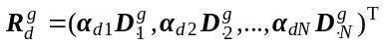is the reconstruction vector.
6 Experiments
In order to evaluate the performance of our proposed method, experiments were executed on two complex public traffic datasets, namely QMUL Junction dataset and AVSS dataset. The proposed approach was applied to detect abnormal events in these two datasets, and then the detection results were compared with other state-of-the-art methods to verify the effectiveness of our method.
6.1 BOSS dataset
This dataset is composed of a surveillance video captured on a train. The video is captured at 25 frames per-second, and the spatial resolution is 720× 576 pixels. The content of the video is quite complex and different scenes include various number of people. There are totally 6 kinds of abnormal events including fighting, grabbing cell phone, grabbing newspaper, harassing, fainting and panicking. Fig.2 shows some examples of the video scenes.
The videos of this dataset have been classified into various scenes. Each video was divided into non-overlapping fragments with a length of 4s. We took three quarters of video clips for model training during the experiment, and half of them were used for supervised training while the other half were used as unlabeled samples.
(a) Selection of parameters
The length of trajectories was limited from 10 to 20 to make sure the accuracy. To learn the trajectory descriptors and quantify the video into visual document, we learned the GMM with I=10 components. For the parameter set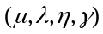, they were supposed to take appropriate values. Too small parameters would lead to a low sparsity model, while a model with highly sparse codes and dictionary might miss some useful information. We experimentally found the best result with the parameter set (0.5,0.35,0.35,200), and the number topics in each category dictionary is set to be 12.
(b) Comparison of representation methods
The short local trajectory was compared with the dense trajectory [21] to verify the effectiveness of the proposed method in video anomaly detection. We also conducted experiments with different trajectory representation methods. In order to fully demonstrate the detection efficiency of the method, the F1-Measure which is defined as the harmonic mean of the precision and the recall is employed to show the performance of our method.
Table 1 shows the detection results using different trajectory extraction and representation methods. From table 1 we can observe that the proposed improved dense trajectory method is more distinguished in video anomaly detection. Trajectory descriptor generated by the fisher kernel performs better than the concatenation. One of the reasons is that the fisher kernel based trajectory feature extraction method does not require a fixed number of interesting points for each trajectory, so it can capture more short-term trajectories and increase the density of the trajectories. In addition, the location and shape information of the trajectory are modeled as a whole, which enhances its structure feature and achieves higher discrimination, thus a more complete codebook can be obtained.
(c) Comparison of different detection methods
We compared the results detected by our method with some other state-of-the-art methods such as GPR[12], JSM[13], and BiSTM[26]. Fig.4 shows the ROC curves of these methods on QMUL Junction dataset and table 2 shows the corresponding AUC values.

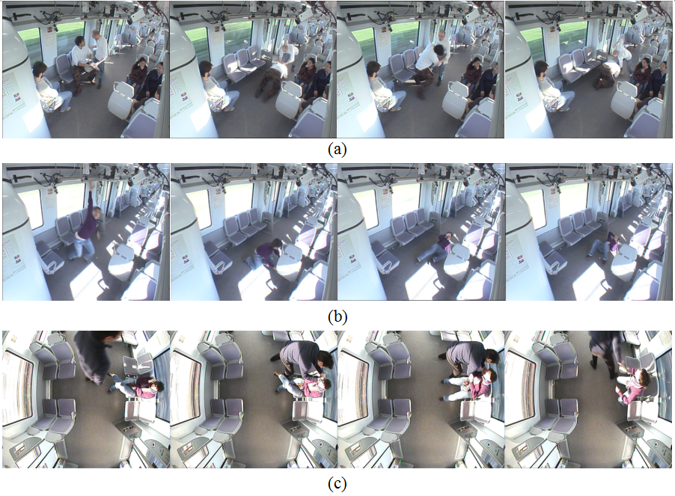
Fig. 4 BOSS dataset: (a) fighting; (b) fainting; (c) grabbing cell phone
Table 1 Comparison of different trajectory extraction and representation methods using F1-Measure
Trajectory methods | Trajectory representation | Unsupervised method (F1) | Semi-supervised method (F1)
Dense trajectory | \ | 0743 | 0.754
Short local trajectory | \ | 0.735 | 0.782
Short local trajectory | Concatenation | 0.772 | 0.803
Short local trajectory | Fisher kernel | 0.798 | 0.846

6.2 CAVIAR Dataset
The first set of this dataset was adopted in our experiment. The video is captured with a wide angle camera. The resolution is half-resolution PAL standard (384×288, 25 frames per second). This dataset contains different scenarios including people walking alone, meeting with others, window shopping, entering and exiting shops, fighting and passing out. Fig.6 shows some typical abnormal examples of CAVIAR dataset. We use same approach to train the model as described above. The parameters 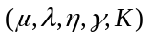were set to be (0.5,0.38, 0.38,230,10).
The ROC curves of different methods on CAVIAR dataset are shown in Fig.6 and the AUC performance is summarized in table 4.

